

Foundations of Programming

Assignment No. : 06
PROBLEM STATEMENT:Write a C function to compute the factorial of a number with and without recursion.

OBJECTIVE:

To demonstrate two different approaches for calculating the factorial of a number: iterative (non-recursive) and recursive, showcasing the versatility of problem-solving methods in programming.

THEORY:
- Explain the difference between the iterative and recursive approaches to calculating the factorial of a number.
- What is the base case in the recursive function for computing factorials, and why is it necessary?
- How does the program handle invalid input, such as negative numbers, and why is this important?

THEORY:
1: Start
2: Read and input a number from user and store as num
For iterative
3: Initialize fact, i as int variables
4: Loop i from 1 to number,
fact=fact*I,
5: Display fact as Factorial
6: Stop

For recursive:
3: Initiallize fact
4: fact=fact (num), where fact( ) is a recursive function
5: Display fact as factorial
6: Define recursive function fact(n)
In the function,
7: if (n>= 1)
return n* fact (n-1);
else
return 1;
8: Stop

FLOWCHART:

i) Iterative
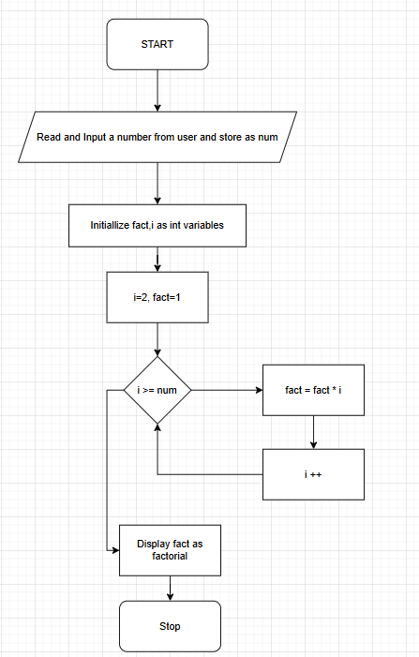

ii) Recursive
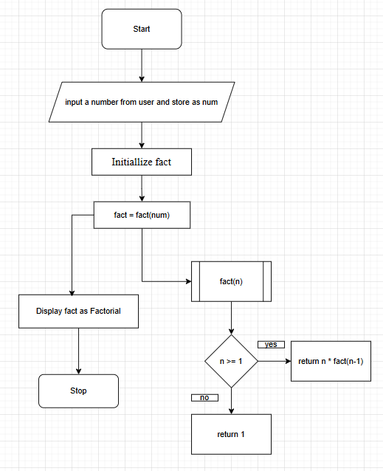

CODE:

i) Iterative
#include <stdio.h>

int main()
{
int num, i;
int fact = 1;

// Input
printf("Enter a number: ");
scanf("%d", &num);

// Loop for factorial
for(i = 1; i <= num; i++)
{
fact = fact * i;
}

// Output
printf("Factorial = %d", fact);

return 0;
}

ii) Recursive
#include <stdio.h>

// Recursive function
int fact(int n)
{
if (n <= 1)
return 1;
else
return n * fact(n - 1);
}

int main()
{
int num, result;

// Input
printf("Enter a number: ");
scanf("%d", &num);

// Function call
result = fact(num);

// Output
printf("Factorial = %d", result);

return 0;
}

PLATFORM: Linux

INPUT:
OUTPUT:
CONCLUSION: Thus, we have successfully executed factorial of a number with and without recursion.

FAQs:
1. What is the purpose of calculating factorial in programming?
2. What is the difference between recursive and non-recursive (iterative) methods?

